**Aquafira: The Chemosynthetic Exoplanet**

Juan José Becerra Bedoya, Sary Alejandra Garcia Sierra, Nina Isabel Yanes González, Jhohan Mauricio Jiménez David, María Esperanza Medina Carmona y María Fernanda González Paniagua

Research Group ITM

October 6, 2024

**Objetives**

To create a world where, through its various chemical elements, life based on chemosynthesis can exist. In this world, autotrophic microorganisms such as bacteria can be found, which generate sustainable energy for microbial life by oxidizing chemical compounds. Both exogenous and endogenous conditions of the oceanic environment must be considered.

**Version control**

|  |  |  |
| --- | --- | --- |
| Version | Date | Realised changes |
| 0 | 6th September  2024 | Creation of the doc |

|  |  |  |
| --- | --- | --- |
| Elaborated and valided | Support and check | aprove |
|  |  |  |
|  |  |  |

# Abstract

Chemosynthesis allows us to expand the concept of life, offering new possibilities for sustainable ecosystems that do not depend on sunlight. This process, typical of autotrophic microorganisms, demonstrates that life could thrive in extreme environments, such as beneath the surface of oceanic ecosystems. These microorganisms form the base of a food chain that supports greater biodiversity, suggesting that life could exist in a variety of previously overlooked habitats. We developed a model of a celestial body capable of sustaining life through chemosynthesis, tackling the challenge of discovering life forms in environments unlike Earth.

Our study examined the essential conditions for life on such a body, including its spatial location, climate, and the types of bacteria capable of thriving in these environments. Using specialized simulations, we modeled these conditions and created visual representations of potential ecosystems and species. This innovative approach opens new possibilities for the search for extraterrestrial life, offering a fresh perspective on how life might evolve without reliance on sunlight. The results are aimed primarily at astronomers focusing on the search for celestial bodies that could harbor life, encouraging a broader exploration of all potential forms of life beyond traditional Earth-like environments.

# Introduction

Chemosynthesis was first identified as the foundation of a food web in 1977 during an oceanographic expedition near the Galapagos Islands. Researchers discovered hydrothermal vents on the ocean floor, releasing a hot chemical-rich fluid that supported thriving communities of giant tube worms. Around these hydrothermal vents, a variety of new animal species were observed, flourishing despite the complete absence of sunlight. Since this discovery, similar remarkable ecosystems have been found in hydrothermal vent fields and cold seep sites across the globe.

Chemosynthesis is characteristic of certain microorganisms, specifically bacteria with autotrophic capabilities, which produce energy by oxidizing chemical compounds. These bacteria, known as chemoautotrophs or chemolithotrophs, play a crucial role in sustaining life in extreme environments.

With the aid of the James Webb Telescope, our understanding of the universe’s complexity has deepened, as the telescope has detected distant galaxies that were previously beyond the limits of our observable universe. As Devos stated, "We can no longer say that bacteria are simple and have not evolved. In fact, we ourselves, and everything visible to the eye, are the result of the evolution of bacteria." This highlights the profound role microorganisms play in the evolution and diversity of life.

For many years, humans have been intrigued by discovering what lies beyond our planet Earth. They have strived to take their knowledge to the cosmos and delve deeper into it. We have often wondered whether we are alone in this vast universe, as it is not difficult to imagine the existence of life on other planets or celestial objects. As we explore further, we discover that the universe is expanding; "It has been observed that the distances between the large structures of the universe (clusters and superclusters of galaxies) progressively increase. This observational fact is called the expansion of the universe and was discovered by Edwin Powell Hubble and Milton Lasell Humason in 1929." Similarly, with the help of the James Webb Telescope, we have been able to expand our knowledge of the universe's complexity, as it has managed to detect very distant galaxies that were not previously within the observable part of what we knew.

Based on various investigations conducted by NASA, questions arise about the possibilities of life in other worlds and the different forms it can take there. In other worlds different from Earth, chemical elements similar to those found on Earth have been discovered. Based on this, there is enthusiasm to think that with the basic components for life, such as the presence of certain chemical elements, life can occur in a way different from what we commonly know, an example of which is chemosynthesis. Chemosynthesis allows us to imagine a world teeming with microorganisms, which, through chemical elements and without the presence of sunlight, have the ability to create energy for their sustenance. These primitive microorganisms are the beginning of a food web that can develop and eventually evolve into an ecosystem.

According to some research, it is believed that the first living being to inhabit Earth was a bacterium. "Scientists believe that all living beings on the planet descend from a single organism known as LUCA (Last Universal Common Ancestor). It was the first to perform all the physical and chemical processes necessary for 'life' as we know it, billions of years ago." It is believed that this first being withstood and evolved under the conditions of that time, with its development process possibly occurring through chemosynthesis, based on the geochemical environment. These bacteria are the fundamental basis in the constitution of life as we know it today. Therefore, chemosynthesis itself is the origin of a form of life and the beginning of others.

"We can no longer say that bacteria are simple and have not evolved. Yes, we ourselves, and everything that can be seen with the eye, are the result of the evolution of some bacteria." – Devos.

The knowledge of what chemosynthesis is and how it develops is fundamental to understanding the origin, development, and evolution of life. It provides us with a broad understanding of how it began, from obtaining a simple form to creating a chain that generates a more complex life. In our chemosynthetic world, we find autotrophic microorganisms as a form of life that can live beneath the surface in an oceanic ecosystem. These can, in turn, build a series of food chains with other species, thereby generating diversity.

## STAGES OF CHEMOSYNTHESIS

There are two stages: Oxidation and Reduction. **OXIDATION** – ATP and NADH are obtained. ATP (Adenosine Triphosphate) and NADH (Nicotinamide Adenine Dinucleotide) are energy molecules. Their function is to provide energy to activate biochemical reactions inside the cell, maintaining active functions such as DNA and RNA.

**REDUCTION** – CO2 is reduced to form glucose and amino acid molecules.

**TYPES OF BACTERIA**

* **Nitrogen Bacteria**: Nitrosifying bacteria oxidize ammonia to nitrites (NH₃→ NO₂) and nitrifying bacteria oxidize nitrites to nitrates (NO₂ → NO₃).
* **Sulfur Bacteria**: H₂S→SO₃⁻²→SO₄⁻⁴ They oxidize hydrogen sulfide to sulfites and from sulfites to sulfates.
* **Iron Bacteria**: They oxidize ferrous ion to ferric ion Fe ² → Fe ³.
* **Hydrogen Bacteria**: These bacteria oxidize hydrogen to water. H₂ + 1/2 O₂ → H₂O
* **Methane Bacteria**: They oxidize methane to carbon dioxide CH₄ + 2O₂ → CO₂ + 2H₂O

# Metodology

Our project is based on the analysis of the natural satellite AQUAFIRA. It consists of geochemical conditions that may contribute to the generation of microbial life through chemosynthesis, for this we investigated multiple web sites and data bases that included information which might help build this microorganism.

Now to closely approximate how this body would behave in space, we decided to compare it to Saturn's moon, Titan. We used similar masses and distances, scaling them appropriately to simulate the behavior of these bodies. We chose to create two simulations: one in Unity and the other in JavaScript, as we had experience with both languages. This allowed us to explore the same celestial bodies from two different programming perspectives.

# Results

## Biological and astronomical aspects

AQUAFIRA is the natural satellite of the planet Odysseus. The distance between them is 1,221,900 km, and from the Sun, the distance to AQUAFIRA is 1,419.2 million kilometers. It is a dark satellite where little sunlight reaches due to the density of its atmosphere. As a result, it is a very cold satellite. It has a solid-state oceanic environment, but beneath this layer, there is a liquid ocean. At certain depths, there are hydrothermal vents heated by core activity. These vents expel water at temperatures of up to 4 degrees Celsius, which helps to warm the cold ocean water that later exits. These vents contain a number of minerals and the presence of reduced sulfur compounds such as hydrogen sulfide, elemental sulfur, and thiosulfate, which gives life to sulfuroxidizing bacteria. These bacteria obtain energy for their metabolism from oxidation reactions.

## 3.1.1. Characteristics & conditions

**Table 1**

*Sulfur-oxidizing Bacteria, characteristics & conditions*

|  |  |
| --- | --- |
| **Characteristic** | **Description** |
| **Discovery and Isolation** | Solated in 2007 from the soils of the Hell’s Gate  geothermal area, New Zealand. |
| **Clasification** | Phylum: Verrucomicrobiota; Class: Methylacidiphilae;  Order: Methylacidiphilales; Family: Methylacidiphilaceae. |
| **Shape and Mobility** | Not movile bacilo. |
| **Optimal Growth Conditions** | Grows in extreme conditions: pH between 2.0-2.5 and  temperature of 60°C. |
| **Meabolist** | It's an obligate methanotroph, using methane (25% v/v in air)   and requiring CO2 to grow (8% v/v in air). |
| **Genome** | Circular genome with 2,287,145 base pairs. It encodes a  methane monooxygenase but lacks known genetic modules  for the oxidation of methanol and formaldehyde. |
| **Key Metabolic Pathways** | It can synthesize most amino acids, nucleotides, and cofactors,  except cobalamin. |
| **Adaptation to Acidic Environments** | It possesses enzymes such as glutamate decarboxylase and  antiporters that allow it to survive in extremely acidic conditions. |
| **Ecology importance** | Lives in extremely acidic environments with high methane  concentrations, contributing to carbon cycles in geothermal ecosystems. |

**Image 1**

*Sulfur-oxidizing Bacteria*

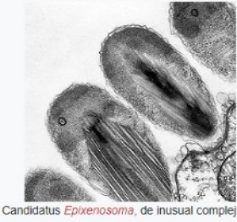

**Diagram 1**

*Characteristics of Aquafira satellite*

**Entorno de la bacteria**

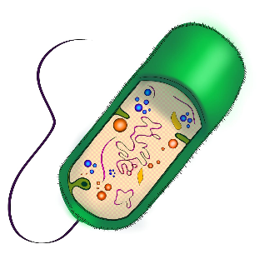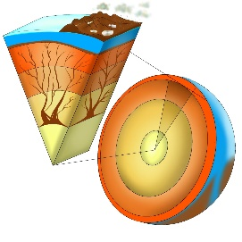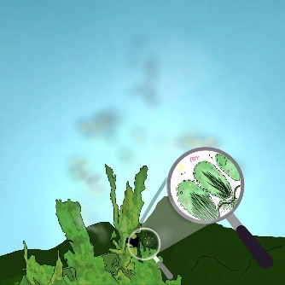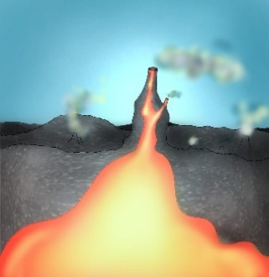

**Image 2**

*Aquafira trayectory (green)*

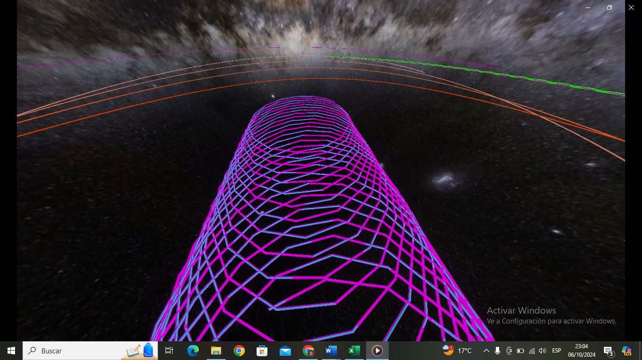

**Images 3 – 6**

*A close look to the planets used in the simulations*

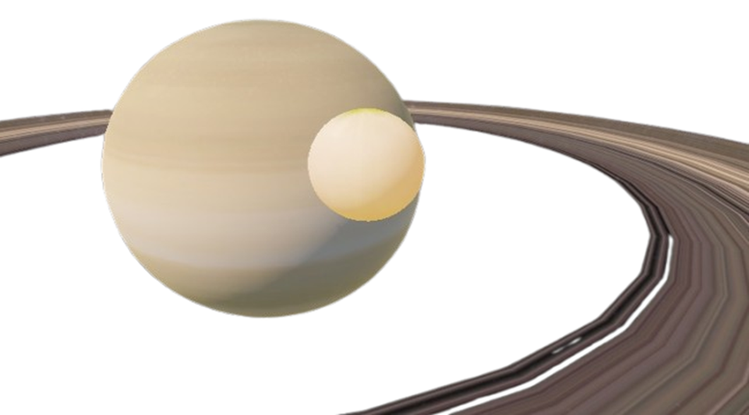

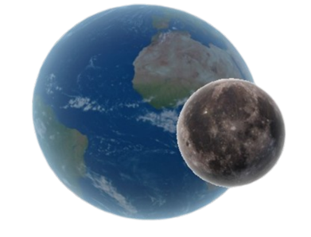JANO and its moon CUPIDO

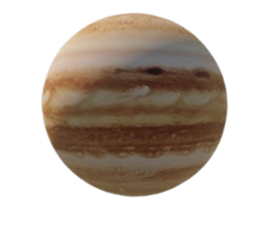POSEÍDONES

**The star** BAKO

# Discussion

**Chemosynthesis**, the process by which certain organisms, such as Methylacidiphilum infernorum, obtain energy by oxidizing chemical compounds instead of relying on sunlight, represents a key mechanism for the survival of life in environments where sunlight is scarce or nonexistent, such as the Earth's deep ocean floors or possibly beneath the thick ice layers covering moons like Titan. In fictional worlds similar to Aquafira, where extreme temperatures, methane-rich atmospheres, and seas of hydrocarbons prevail, chemosynthesis could play an equally fundamental role, enabling the emergence of complex ecosystems despite the complete absence of light.

However, it is important to acknowledge the inherent limitations of this metabolism compared to photosynthesis. By generating less energy from chemical substrates, chemosynthetic ecosystems would likely be restricted in their diversity and complexity relative to those sustained by terrestrial photosynthesis, likely consisting of organisms directly dependent on methane oxidation, like M. infernorum, and a shorter food chain with less capacity to support higher life forms.

The scenario on Aquafira presents extraordinary biological challenges, such as hypercritical temperatures of -179°C, high atmospheric pressure, and seas composed of liquid methane and ethane. Nevertheless, extremophiles like Methylacidiphilum infernorum demonstrate the potential for life even under such extreme conditions, developing biochemical mechanisms that allow them to survive in acidic, light-deprived environments. Chemosynthetic organisms, such as methanotrophs, could find in this world a unique opportunity for their metabolism to thrive.

This raises the essential question of whether terrestrial biology could directly adapt to the harsh conditions of a moon like Titan or if a prolonged in-situ evolutionary process would be required. In some respects, Aquafira resembles primordial Earth, when the atmosphere contained high concentrations of methane and ammonia and lacked oxygen. This suggests that a world like Aquafira could represent a "primitive" version of life’s evolution. On Earth, life based on chemosynthesis may have preceded photosynthesis, which opens the possibility that, in these extraterrestrial worlds, life might be in an early stage of its evolution.

# Conclusions

The development of a chemosynthetic ecosystem based on conditions similar to Saturn’s moon Titan or a fictional world like Aquafira allows us to explore the possibilities of life in extreme environments. Through the study of organisms such as Methylacidiphilum infernorum, we can imagine how life forms might adapt and thrive without sunlight, using methane as an energy source.

However, this poses scientific challenges that must be carefully considered as we explore the possibility of extraterrestrial life.

The most relevant points are summarized here, as someone will evaluate whether the objectives of the challenge and those set by the group are fully met based on these conclusions. Therefore, it is recommended to include a conclusion that addresses the key points related to each objective, both those of the NASA Space Apps challenge and your own group’s goals.

# Glosary

**Cosmos**: The universe considered in its entirety, including everything that exists: stars, planets, galaxies, space, and energy.

**Clusters**: Groups of galaxies bound together by gravity. They are part of the large-scale structure of the universe.

**Superclusters**: Even larger structures formed by several galaxy clusters. They are the largest known groupings in the universe.

**Expansion of the universe**: An observed phenomenon where the distances between galaxies and galaxy clusters increase over time, indicating that the universe is expanding.

**Chemosynthesis**: A process by which certain microorganisms generate energy by oxidizing chemical compounds without the need for sunlight. This process enables life in extreme environments, such as the ocean floor.

**LUCA (Last Universal Common Ancestor)**: Refers to the most ancient organism from which all current living beings descend.

**Geochemical**: Related to the chemical composition of the Earth or other planetary bodies. It refers to the study of the chemical elements present on a planet and their interactions.

**Autotroph**: An organism that can produce its own food from simple inorganic substances, such as sunlight (photosynthesis) or chemical compounds (chemosynthesis).

**Oceanic ecosystem**: The community of living organisms and their environment in the oceans. Oceanic ecosystems include organisms ranging from the smallest, like bacteria, to the largest, like whales.

**Food chain**: A sequence of organisms that rely on each other for food, starting with autotrophs that produce their own food and ending with higher-level consumers.

**Microbial life**: Life forms composed of microorganisms, which are tiny organisms such as bacteria, fungi, and viruses, invisible to the naked eye. These organisms are crucial to the balance of many ecosystems.

**Exogenous conditions**: Factors or conditions that originate from outside a system or environment. In the context of life on other planets, it refers to external influences such as cosmic radiation, meteorite impacts, or solar energy.

**Endogenous conditions**: Internal factors or conditions within a system or environment. In planetary terms, this would include aspects like volcanic activity, tectonic plate movement, or a planet's chemical composition that affect the potential for life.

**Autotrophic characteristics**: The property of autotrophic organisms, those that can produce their own food from inorganic substances. Examples include plants (which perform photosynthesis) and certain microorganisms (which perform chemosynthesis).

**James Webb Telescope**: An advanced space telescope launched in 2021, designed to study the most distant galaxies and the earliest stages of the universe. It uses infrared technology to observe celestial objects that were previously invisible with earlier telescopes like the Hubble.

# References

* *Quimiosíntesis - Google search*. (s/f). Google.com. Recuperado el 7 de octubre de 2024, de https://www.google.com/search?sca_esv=ef8e62f25627cfa6&sxsrf=ADLYWILDXZ65hdvtCrsiTrasnLbNMtNQLg:1728144876716&q=quimios%C3%ADntesis&tbm=vid&source=lnms&fbs=AEQNm0CbCVgAZ5mWEJDg6aoPVcBgWizR0-0aFOH11Sb5tlNhd3zC4y7ZXTSrvvSBSNjw8fViXBe1-ue1pgc4W77YHGSo5xYtnFlb-xea5tkJyrw0DuAEh4FO4nCn3Xjq1QBWtDljQgeVgmhnqwt3UxuoDISsnbs1C-2RDdXYPRNnQrI8n6H2u1BL_VicIcwP4lp5WdNG8yxh4yOTY27lLCVAi9SteJoigw&sa=X&ved=2ahUKEwjC2Pyr0feIAxU5QjABHW05E_wQ0pQJegQIFxAB
* *Titan: Facts. (2018, mayo 2). Nasa.gov.* [*https://science.nasa.gov/saturn/moons/titan/facts/*](https://science.nasa.gov/saturn/moons/titan/facts/)
* Torres, F. H. (s/f). *GoConqr - Quimiosíntesis*. GoConqr. Recuperado el 7 de octubre de 2024, de <https://www.goconqr.com/es/p/7188432?canonical=true&frame=true&no_cache=true>
* Hall, L. (2020). *Space Apps Challenge*. https://www.spaceappschallenge.org/nasa-space-apps-2024/challenges/beyond-sunlight-an-aquatic-chemosynthetic-world/